Reedy Baseball Summer Weight Training

Suggestions:
- Do not lift on your game day
- Make sure you give yourself a day rest in-between your lifts
- Depending on your game schedules, try to get 3 lifts in a week
- Eat something high in protein within 1 hour of lifting (Ex. Peanut butter sandwich)
- Pitchers – run at least ten 60 yard sprints on your non-lifting days to aide in relieving the soreness you will have between lifts
- Do your band routine and hanging stretches after your lift.

Day 1
- 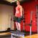

Dumbbell Step Ups
5 sets of 5 reps
Rest: 60 seconds
- 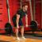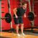

Bent Over Barbell Row
3 sets of 10 reps
Rest: 45 seconds
- 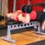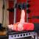

One Arm Dumbbell Bench Press
3 sets of 15 reps
Rest: 30 seconds
- 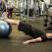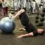

Ball Leg Curl
3 sets of 8 reps
Rest: 30 seconds
- 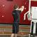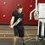

Double Kneeling Cable Chop (Shown standing)
3 sets of 10 reps
Rest: 30 seconds
Day 2
- 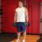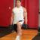

Dumbbell Rear Lunge
3 sets of 8 reps
Rest: 60 seconds
- 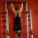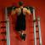

Pullups
3 sets to failure
Rest: 45 seconds
- 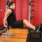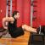

Bench Dips
3 sets of 6 reps
Rest: 60 seconds

Kneeling Medicine Ball Chop (Shown standing w/ cables)
3 sets of 12 reps
Rest: 45 seconds
- 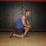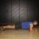

Plank
3 sets to failure
Rest: 45 seconds

Day 3
- 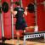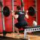

One Leg Barbell Squat
4 sets of 8 reps
Rest: 60 seconds
- 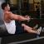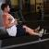

Seated Cable Rows
4 sets of 10 reps
Rest: 45 seconds
- 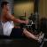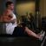

Seated One-arm Cable Pulley Rows
3 sets of 12 reps
Rest: 30 seconds

Half-Kneeling Low-to-High Cable Chop (Shown standing)
3 sets of 15 reps
Rest: 30 seconds
- 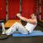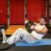

Russian Twist
3 sets of 12 reps
Rest: 30 seconds

