Reedy Baseball Hitting Drills: “Leave the bugs alone!!!!”

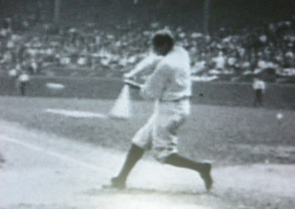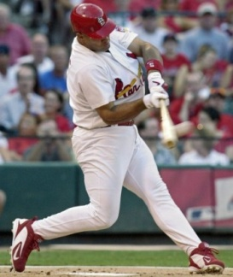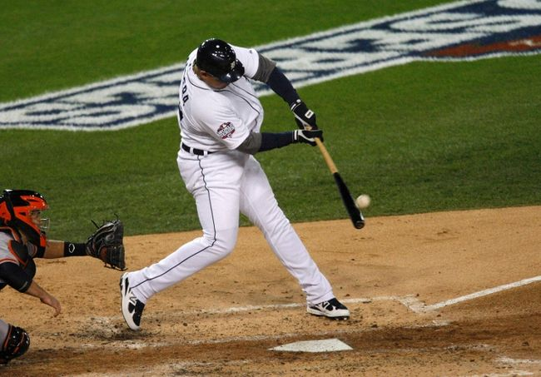

  - Lower half drills – NO BUG SQUASHING!
    - Slap drill – coach is on a knee in front of the hitter, with his hand/pillow in the middle of the plate. The hitter then uses his top hand only to slap the coach’s hand/pillow. The emphasis is on pushing the back knee forward and not “squashing the bug”. I want all my momentum heading straight ahead and not backwards. The hitter will finish with his foot perpendicular to the ground…up on the back toe.
    - Knee punch – coach is still on a knee in front of the hitter with his hand placed in the middle of the hitter’s knees. The hitter will be instructed to drive his back knee on command into the coach’s hand. Tell the hitter that he has to knock the coach’s hand forward at least a foot in distance. This will train the hitter to get his momentum going forward and to use the back hip effectively.
    - Happy Gilmore – ball is placed on the tee with hitter positioned one full step behind the tee. The hitter will take one shuffle step towards the tee, swing, and then drive the back knee forward to chest level. If they are falling back and not getting their momentum going forward, have them take two additional steps forward after driving the back knee forward. We are trying to get the hitter to feel driving the back hip forward.

POINTS OF EMPHASIS – Throw the back knee/hip towards the pitcher to get the lower half into the swing, emphasis on the lower half will lead to quicker hands (sounds weird, but true!), get up on the back toe on the finish of the swing…check Babe Ruth in the above picture

Notes: ________________________________________________________________________________________________________________________
  - Correcting the Uppercut – GET THE LOOP OUT!
    - Double Tee – Place one tee at the front of the plate and one tee at the back of the plate at a level one inch below the front tee. The ball will be placed on the front tee. Have the hitter attempt to hit the ball without hitting the back tee. This drill will correct the loop/upper cut in the swing. If the hitter is consistently hitting the back tee, then his swing path is incorrect. Emphasize that the hitters drive the knob of the bat to the ball with the hope of slicing the ball in half with the knob…that will keep the swing flat
    - High Tee – Place a tee at chest level (may have to put a tee on a bucket for proper positioning). The athlete will “throw the knob” at the ball, trying to slice the ball in half. The only way that the hitter will be able to hit the ball off the tee clean and at a point straight ahead, is if the hitter has a flat swing. You can also implement the Double Tee Idea for the High Tee drill as well.
    - Stop at Impact (front toss) – throw front toss in three locations – down the middle, inside, and outside. For the first 5 throws, have the hitter stop the bat at contact. You can see a lot from this…are the hitter’s hands in proper position (right hand up, left hand down for righty), is the swing flat, is the right elbow tight to the ribcage? After 5 throws, let them then finish the swing. This drill is also great for developing forearm strength.
    - Others – “Throw the Fungo”, “Hit Uphill”, “Top-Hand Only”
POINTS OF EMPHASIS – Tell the hitter to throw the knob of the bat at the ball…we want to slice the ball in half with the knob (knife and watermelon analogy), this should keep the bat “flat” through the hitting zone…goal is for the bat to be as flat as possible from the back of the plate to the front of the plate.
Notes - ________________________________________________________________________________________________________________________

  - Correcting the “Bat-Wrapper” – PUSH THE HANDS BACK, NOT THE BAT!
    - Waggle drill – have the hitter wiggle, waggle, wave, or do circles with the bat at their normal hand position as you are throwing them front toss. This forces the batter to get his hands in proper position quickly as the ball is thrown. The hitter does not have time to wrap.
    - Crazy Hands – put the hands in an odd position (ex. Hands at the front shoulder instead of the back shoulder) as you throw front toss. To hit the ball effectively, the hitter will get the hands in the hitting position and will not have time to wrap the bat behind his head.
    - Bunt-Slash Tee – The hitter will begin in a bunting stance facing the Tee. Have the hitter perform a slash by quickly pulling the bat back to hitting position and swing. Again, if the hitter is going to make good, solid contact off the Tee, he does not have time to wrap the bat behind his head.
POINTS OF EMPHASIS –If wrapping the bat, tell the hitter to push the bat back with his top hand instead of bottom…this should help keep the proper angle of the bat.
Notes - ________________________________________________________________________________________________________________________

  - Correcting the “Bucket/High Stepper” – YOU ARE NOT THE KARATE KID! SLIDE THE FOOT, DON’T LIFT THE FOOT.
    - Mr. Board – cut a 2x4 or 2x6 piece of wood into 5 ft. sections and set a Tee up for the hitter. Have the hitter get in his stance on top of the board (on the balls of his feet). Have him take normal swings on the board. If he is stepping high or out, this drill will force him to step straight ahead or he will get frustrated with constantly falling off the board. If he is a kid that has too long of a stride, put him 4-6 inches from the front of the board, so he is forced to only take a short stride or fall off the front of the board.
    - Mr. Board Part Deux – For the hitter that steps out on the inside pitch, place a board behind his front foot, and a board 4-6 inches in front of his front foot when throwing live to the hitter. This should help deter the hitter from stepping out and over-striding with a bucket step.

POINTS OF EMPHASIS – All momentum should be headed toward the pitcher…stepping out prevents this from happening.

Notes - ________________________________________________________________________________________________________________________

Overall hitting philosophy – try to correct a kid through drills and not words. A lot of times they do not “get it” when we are telling them that they are wrapping the bat, or over-striding, or lifting…give them a drill to fix it and emphasize the positives of their swing.

