RHS Baseball Summer Agility Training

Suggestions:
- Pick 2 of the agility drills below and do them twice a week during the summer
- Every week, pick two new drills
- Try to get together with teammates so that you can push each other during the drills

Drill: Pro Agility

- Start in a 2-point stance straddling the starting line
- Open to your right or left; sprint 5 yards; touch the line with your hand
- Turn and sprint 10 yards and touch the line with your hand
- Turn and sprint 5 yards through the finish line
Days a week: 2 / Reps: 2-4 / Rest: 1-1.5 minutes

Variations: Scramble starts (start on your stomach, back, etc.); use a different skill in each leg of the drill (shuffle, backpedal, carioca, etc.); increase distance to a 7-14-7.

Late Summer Transitions:
- During fall ball, use the 7-14-7 and rest 1-1.5 minutes
- During January ball, use the 5-10-5 and rest 40-45 seconds
Benefits: The Pro Agility helps infielders work on dropping their center of gravity when fielding ground balls. Pitchers and catchers work on quickness for fielding bunts. All players work on the transition from the batter’s box to the sprint to first.
Key Point: Make sure direction changes are quick and clean.
Coaching Point: “Palm the line to work on really dropping your center of gravity. This is especially helpful for infielders working to get low for ground balls."

Drill: 4-Corner
- Start with four cones in a square pattern, each 5-7 yards apart
- Begin on the right side of cone 1 and sprint to cone 2
- Stay to the outside of the cone and sprint to cone 3
- Sprint around the outside of cone 3 to cone 4
- Stay to the outside of cone 4 and sprint to the finish line
Days per week: 2 / Reps: 2-4 / Rest: 1-1.5 minutes
Variations: Scramble starts (start on your stomach, back, etc.); use a different skill in each leg of the drill (shuffle, backpedal, carioca, etc.); change the distance of the cones; change your running direction and cut.

Late Summer Transitions:

- During fall ball, just sprint around the cones in a square; work up to different patterns and rest 1-1.5 minutes
- During January ball, use more complex patterns and rest 40-45 seconds
Benefit: The 4-Corner Drill is key because of the variations and progression you can have with it.
Key Points: Quick, clean change of direction; drop your hips when cutting around cones

Drill: Agility Wheel

- Set up 9 cones in a circle, each cone 5-7 yards apart (see sketch)
- Stand in the center of the circle at cone 9
- On command, sprint to cone 1, then back-pedal back to the center
- Sprint to cone 2 and sprint back to the center
- Shuffle to cone 3 and shuffle back to the center
- Sprint to cone 4 and sprint back to the center
- Backpedal to cone 5 and sprint back to the center
- Sprint to cone 6 and sprint back to the center
- Shuffle to cone 7 and shuffle back to the center
- Sprint to cone 8 and sprint through the center
Days per week: 2 / Reps: 2-4 / Rest: 1-1.5 minutes
Variations: Change distance of cones; change skills performed in each leg of the drill

Late Summer Transitions:

- During fall ball, use Agility Wheel in place of Star Drill (below)
- During January ball, use Star Drill in place of Agility Wheel
Benefits: “The Agility Wheel is good in the fall, because it’s longer than the Star Drill,” Dendas says. “It builds leg endurance, and it also has a big cognitive factor to it. The players have to know where they’re going and what they’re doing for each cone.”
Key Points: Focus on quick first step, smooth transitions from different athletic movements and quick, clean direction changes.

Drill: Star

- Set up 6-8 cones in a half-star pattern 5-7 yards apart (see sketch)
- Start in an athletic position at cone 1
- On command, sprint to cone 2; touch the cone with your hand; sprint back to cone 1
- Sprint to cone 3; touch the cone with your hand; sprint back to 3
- Continue until you have touched every cone
Days per week: 2 / Reps: 2-4 / Rest: 1-1.5 minutes
Variations: Change number of cones; change distance between cones; change the order of cones; use scramble starts; use different skills in each leg of the drill

Late Summer Transitions: Same as Agility Wheel.

Benefits: The Star Drill is better in January ball because movements are faster than the Agility Wheel. The cones are close, so you move through the drill quickly.
Key Point: Focus on quick first step and change of direction.

Related Exercises
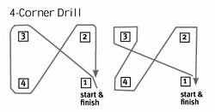
4-Corner Drill

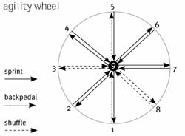

Agility Wheel

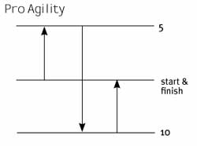
Pro Agility Drill
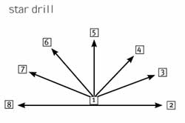
Star

Courtesy of:

Agility drills with Oregon State baseball
September 1, 2005 | Featured in the September 2005 Issue by Chad Zimmerman

