Coach Cox’s Pitching Mechanics and Drills

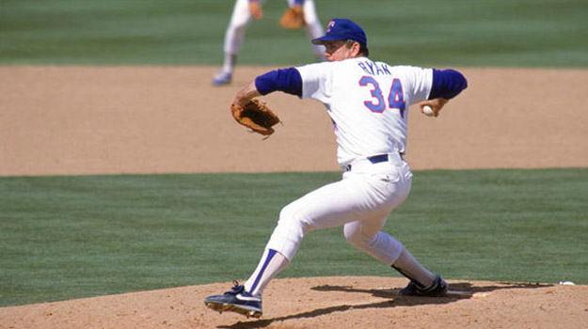

Lead(front) Leg Drive
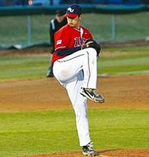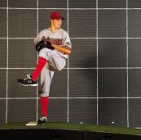
- Torque, torque, and more torque
- Begin placing your back foot on the glove side of the mound…as we progress this will place our release point closer to the middle of the plate
- To get the optimal amount of power from the lower half, our pitchers will drive their lead leg knee back towards 2nd base which will set the hips in a power-position for future hip turn
- The shoulders should be square to the plate (pointing to the plate in a straight line from back shoulder to front shoulder
- Hands should be together near chest level
- Eyes should never leave the catcher’s mitt
- Lead leg heal should be under the knee

Back Leg Drive
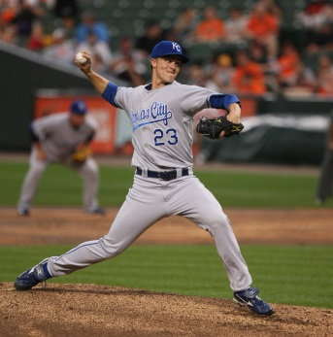
- As we begin moving forward, we will simultaneously break our hands and slightly squat on the back leg to ready the back leg for push or drive (see pitcher on the left)
- We will then push off our back leg towards the plate, never taking our eyes off our target (the mitt)
- The shoulders should still be square to the plate and our arms should be in an elbow to elbow alignment as we approach our landing point

Landing Point

- Upon landing on the front half of our lead foot, we will drive our chest towards our glove which will provide proper rotation and balance our shoulders
- Shoulders are square and eyes are still on the mitt
- The drive leg (back leg) toe should still be on the ground
- Our chest should be behind our lead leg knee

The Finish
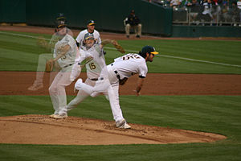

- After releasing the ball the back leg will come off the ground and drift towards the front leg so that we will be in a good fielding position
- Eyes should still be on the mitt
- Your glove should still be close to your chest
- Your throwing hand should be near your hip pocket

Towel Drill
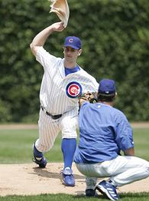

- Out of a stretch position, make a throw with the towel while your partner watches
- Your partner will mark off four foot-to-foot steps from your landing position
- Your partner will then place the glove at your chest height
- You will now complete your throwing cycle by trying to reach out and slap your partner’s glove with your towel.
- Remember to grip the towel like a four seam fastball.

*With this drill you are focused on extending your release point. If you begin to reach your partner’s glove with ease, have him move back slightly.

*Recommended sets would be 3 x 10 throws twice a week

Recommended Grips

4 Seam Fastball
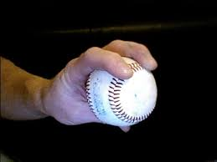
2 Seam Fastball
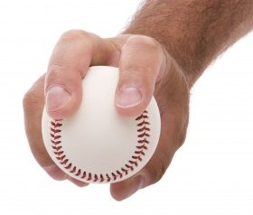
Box Change-up
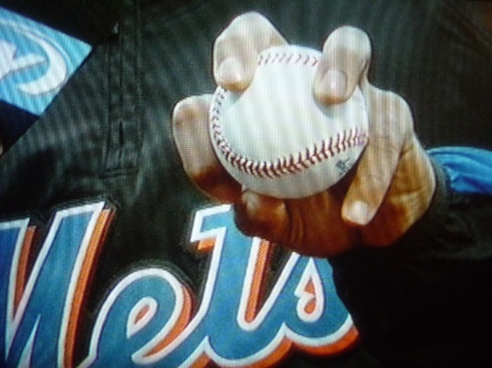
Alternate Grip for Box Change-up
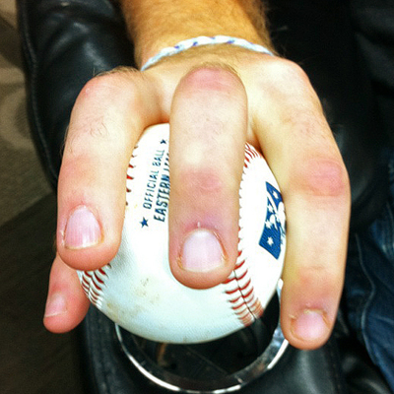
Slider
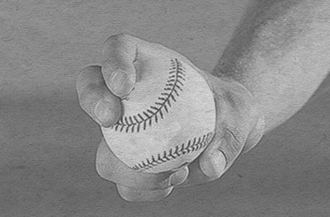
Curveball
